To copy an Agents template, start by selecting "Offices" in the upper navigation bar.

Then on the left-side panel, under the "Setup" menu, select "Copy Templates."

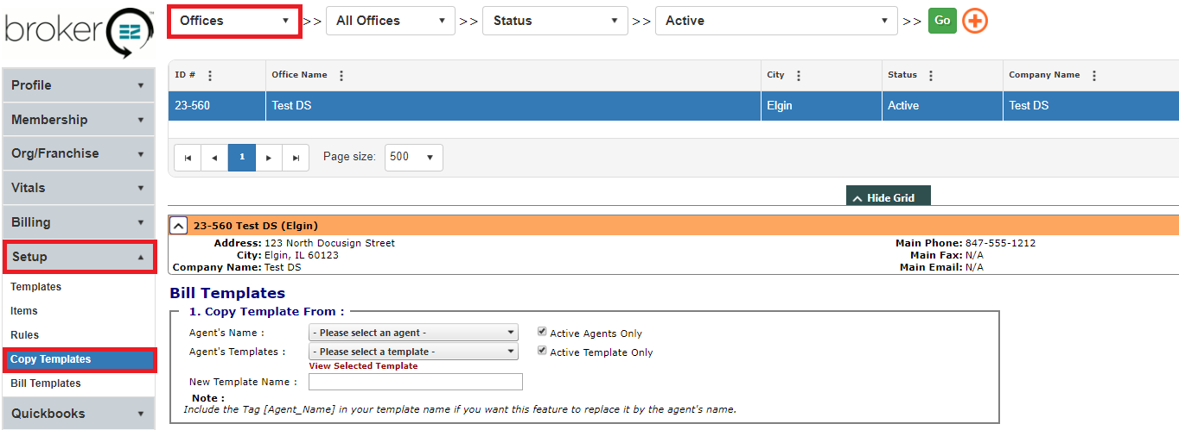

Select the Agent who's template you would like to copy. Then select which template you would like to copy. Make the "New Template" name the same or whatever you like.

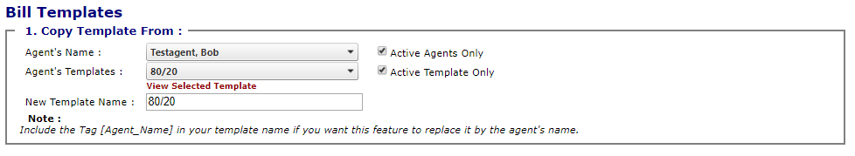

Find the Agent you would like to copy the template to from the list. Once you've found them, click the checkbox next to their name and then select "Copy Template."

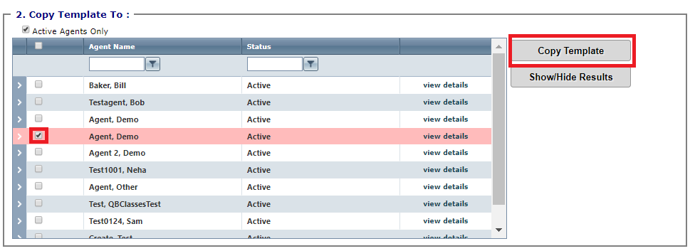

Confirm the template copying and select "Ok."

